
Iceberg Database

NIC Iceberg Naming Convention
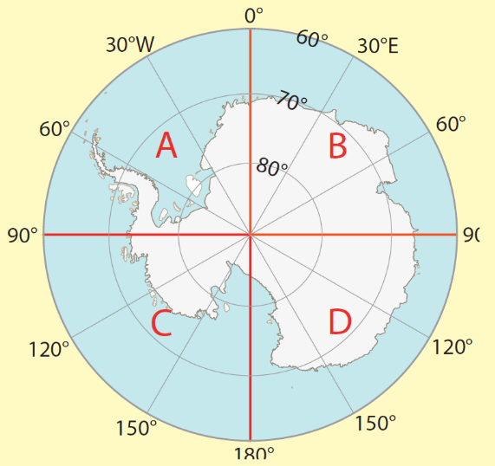
- Bergs must measure 10nm
- Name according to quadrant they calve
- Sequential numbering
- Example:
  - A38 – the 38th berg to calve between 0-90 degrees West (Quadrant A)
- If A-38 breaks into smaller pieces (still > 10nm), assigned letter A38A, B…
- The letter remains the same regardless of drift of berg
- Berg dropped from tracking database when
  - Not sighted after 30 days
  - Drops below 10 nm size restriction for naming
  - Drift north of 60S (Notice to Mariners)

